Dear Parents,

**St Levan Primary**

**School**

**The Bottoms,**

**St Levan,**

**Penzance,**

**Cornwall**

**TR19 6HD**

**secretary@st-levan.cornwall.sch.uk**

[**head@st-levan.cornwall.sch.uk**](mailto:head@st-levan.cornwall.sch.uk)

**Academic year**

**2023 – 2024**

**Autumn term**

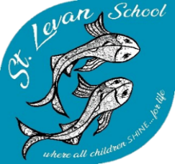Our focus this week has been ‘kindness,’ as you know is one of our many school values.  I have seen so many acts of kindness within school this week and the children did speak fondly about their displays of kindness towards their pets and themselves during our assemblies.  We have read ‘Slowly, slowly, slowly said the sloth and The Smartest Giant in Town together to really highlight really good examples of kindness.  Our ability to be kind to each other is such an important characteristic especially at the beginning of a new year because many aspects of our school are new for many of us.  We’ve celebrated Aila, Rosalee, Taya and Reggie joining our wonderful school with acts of kindness and support and our children have all started their school journey within a new year group.  Our collective gestures of welcome will again be celebrated this evening at the community Ceilidh – I’m looking forward to another wonderful community event at St Levan school and thank you to the Friends of St Levan for organising the event; the benefits of us all gathering together are always so overwhelmingly positive!

As a reminder, please could we draw your attention to our school attendance which is currently a whole school priority and highlight the importance of good attendance across the school for our children.  If, for any valid reason, your child needs to be absent from school at any given time, please notify the school office as soon as you can, either via email or telephone.

There are an increasing number of dogs being brought to the school gate and at times into the school playground by families at pick up time. For many children, to be met by an unfamiliar dog in their safe space at the end or beginning of the school day could be daunting.   Our school dog, Pippin, has been properly trained and has been through appropriate testing to ensure he is safe around children. Additionally, one of his roles is to help children to become comfortable around him and can alleviate some of the fears that many children have about dogs. Therefore, we politely request that if you bring your dog to pick up and drop off your child or children, that it should be on a short lead at the bottom of the drive and is not permitted on the school site for multiple health and safety reasons and primarily for the safety of our pupils.

**Head teacher’s Awards**

**Calum** - for your overwhelming kindness to others, every day.

**Stars of the week**

Choughs Class

Kris – For making a fantastic start to the year – you have shown great resilience and determination – well done!!

Puffins Class

Jack B – for making a simply awesome start to the year!

Thank you for your continuing support,

Mark Francis

Head teacher

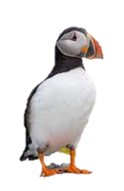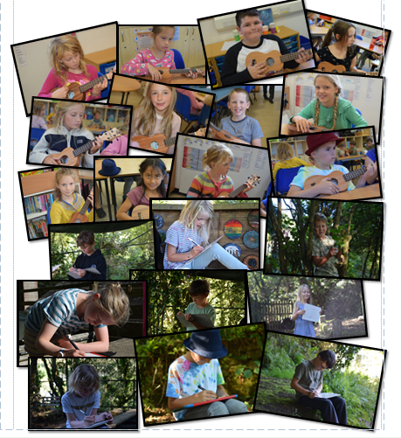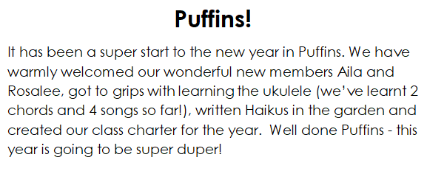

Science in Choughs

In Science, we have been learning about the properties of everyday materials. We looked at a variety of natural materials including beautiful seed pods and nuts and considered words to describe them before discussing how different materials are used for different objects and why. We tested the absorbency of different materials to explore this idea and pondered, why is a glass hammer a bad idea? Why are teapots not made out of chocolate?

“A glass hammer… if you hammer with it, it will break in half– bang! Then all of it. Bad idea! Metal is a good material because it is hard.” - KJ

“The chocolate will melt because the tea is hot. China would be good because it’s hard.” - RTW

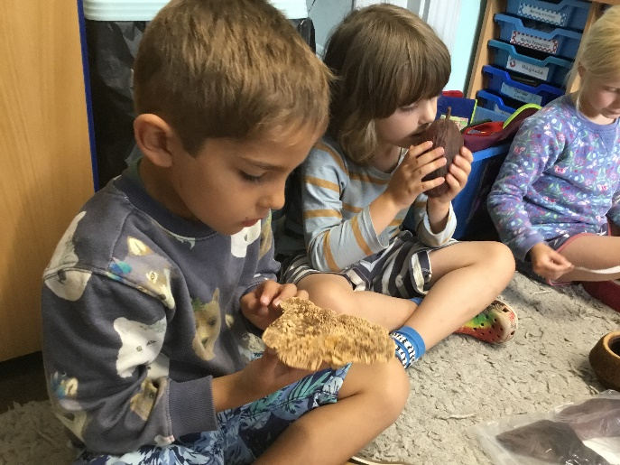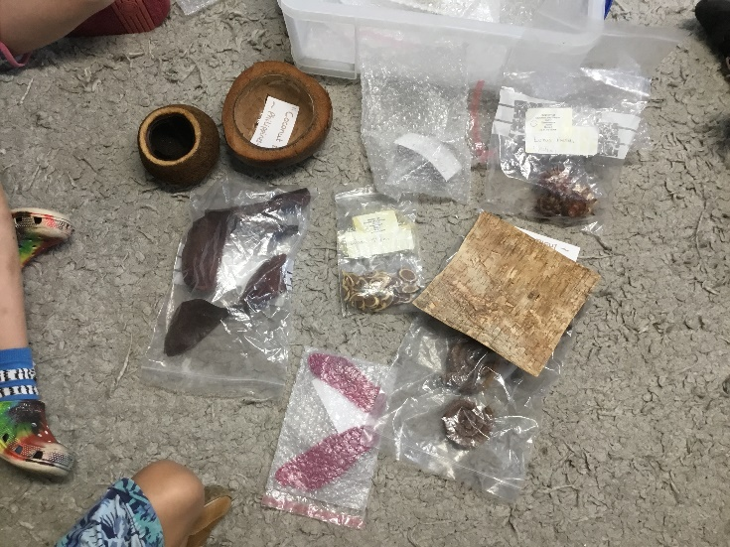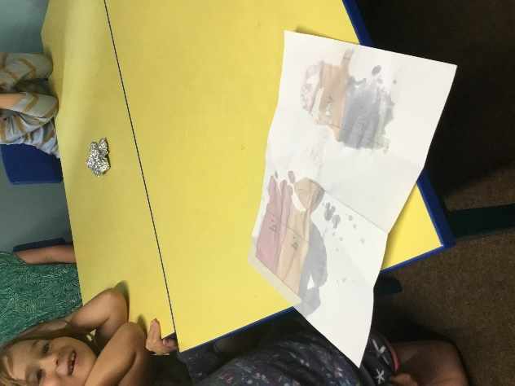

“The tinfoil was the least absorbent in our experiment, then the paper, then the tissue.” - UY

