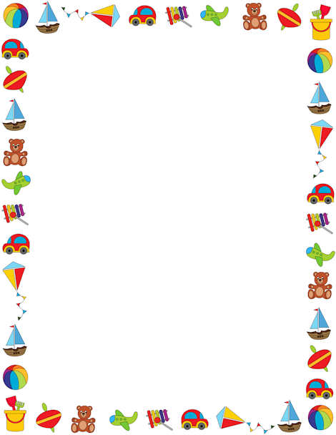
Home Learning Grid for Class 1: Autumn Term 2018
This sheet details some home learning your child could undertake between now and Christmas. Home learning is to be handed in on a Monday so that it can be looked at and books returned, ready for the weekend, on Thursday. It’s always fantastic to see what the children have been getting up to at home. We have our home learning display in class to showcase the children’s learning experiences. Keep learning, and have fun!
Topic: How do you do? | Draw or make a picture of your house and who you live with. You could draw, paint, use photos or all three! Remember to include your pets. | Take one photo a day for a week to tell us a bit about you. | What’s your favourite colour? Create a collage of things you like that are that colour. E.g. Love yellow? Your collage could feature the sun, butter and bananas. | Make a list of three things you are good at, three things you love, three things you dislike and three things you’d like to get better at.
Topic: How do you play? | Go on your own ‘bear hunt’ but look for something else. E.g. you could look for animals, a place or a favourite toy. | Investigate your toys. What are they made out of? Where are they made? Could you sort them into groups? | How do you play…? Write a set of instructions for a game. You could make up your own or use an existing game. You could photos to show us how to play. | Play toy shops. Stick price labels to your toys and use coins to buy them. Use amounts you’re confident with: anything from 1p-10p to £5.00 and above.
Home learning experiences. If you have done something that you feel has been a fantastic learning opportunity, please add it to the grid as your weekly task.

