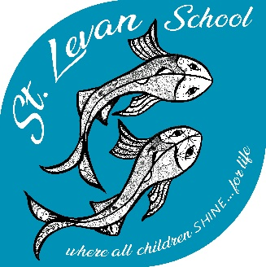

St Levan Primary School

where all children SHINE…for life

The Bottoms, St. Levan, Penzance, Cornwall, TR19 6HD

Tel: 01736 810486

Dear Parents & Carers, Friday 7th May 2021

Please find attached a parent information leaflet about Jigsaw, which is a new Personal, Social and Health Education programme that we intend to implement. This has recently been adopted by other PET schools and aspects of it underpin and strengthen our ethos. This incorporates Relationships & Sex Education, which is now statutory in primary schools from September 2020.

We are hoping that you and your children will embrace this important aspect of your child’s education wholeheartedly but we also need to make it clear that you do still have the right, as parents, to withdraw your child from the sex education part of the programme. The relationships and health education parts are now statutory. We can remove children as appropriate throughout the programme but it would be really helpful to us if they are aware that this may happen and understand the reason from your perspective as parents. It may be useful to keep in mind that children are likely to talk about lessons and information may be passed on from peers, as the guidance states. I have re- printed the DFE guidance to clarify overleaf. We would ask that if you wish that your child does not take part as above that you complete the permission slip at the end of this letter and return to the office. Your child will be cared for and given appropriate alternative learning should this happen.

Because of our mixed age classes, we will separate year groups for these sessions and involve as many staff as possible to provide age appropriate teaching. The full benefits and impact of this new programme will take some time to establish themselves as it is a whole school package covering a wide range of issues over the primary school career. Over time children will build up knowledge, empathy and a self-assured approach to cope maturely with many aspects, including their own and others mental health and emotional wellbeing. We feel the commencement of this very timely and a looking forward to making a start this summer term.

Yours faithfully
Diane Blackie
Interim Head & The St Levan school team

Right to be excused from sex education (commonly referred to as the right to withdraw) DFE guidance 2020
Parents have the right to request that their child be withdrawn from some or all of sex education delivered as part of statutory RSE. Before granting any such request it would be good practice for the headteacher to discuss the request with parents and, as appropriate, with the child to ensure that their wishes are understood and to clarify the nature and purpose of the curriculum. Schools will want to document this process to ensure a record is kept.
Good practice is also likely to include the headteacher discussing with parents the benefits of receiving this important education and any detrimental effects that withdrawal might have on the child. This could include any social and emotional effects of being excluded, as well as the likelihood of the child hearing their peers’ version of what was said in the classes, rather than what was directly said by the teacher. Although the detrimental effects may be mitigated if the parents propose to deliver sex education to their child at home instead.
Once those discussions have taken place, except in exceptional circumstances, the school should respect the parents’ request to withdraw the child, up to and until three terms before the child turns 16. After that point, if the child wishes to receive sex education rather than be withdrawn, the school should make arrangements to provide the child with sex education during one of those terms.

After careful consideration I have decided that my child ____________________________
will not take part in age appropriate sex education as part of the Jigsaw programme.
I have explained to my child that this will be happening and my reasons for it.
Signed Parent/ Carer_________________________

