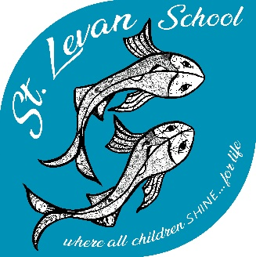

St Levan Primary School

where all children SHINE…for life

Music Policy

School | St Levan Primary School
Date Written | September 2017
Reviewed on | September 2019
Next Review Due | September 2021
I confirm that this policy has been reviewed and adopted by the Governing Body of
St Levan Primary School.

Chair of Governors: Sharon Brolly Date: September 2017

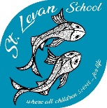
Music Policy

St Levan Primary School
where all children SHINE-for life

Monitoring and review
The Subject Manager is responsible for monitoring the implementation of the policy regularly.
The standards and effectiveness committee of the governing body will monitor this policy on an a three year basis. If the policy appears to need modification, then the committee will report its findings and recommendations to the full governing body.

This policy was approved by the full governing body in September 2017. It is due for review by September 2021.

Rationale
- Music is a powerful, unique form of communication that can change the way pupils feel, think and act. It transcends different cultures, abilities and generations.

- Listening to and making music fulfils an instinctive human need for self-expression and creativity. It stimulates responses both on emotional and intellectual levels.

- Music can be a lifelong source of pleasure. It is education for life.

Aims
To encourage, all pupils to:
- develop musical skills and concepts through listening, appraising, performing and composing.

- develop social skills through co-operation with others in the shared experience of music making.

- develop an understanding of musical traditions and developments in a variety of cultures.

- be motivated to enjoy and succeed in music

Music and the National Curriculum
- Music contributes to the wider aims of Primary Education including, English, ICT, P.E, Art, P.S.H.E. and citizenship.

- Music can develop skills, attitudes and attributes that can support learning in other subject areas that are needed for life and work skills – e.g. listening skills, concentration, creativity, intuition, aesthetic sensitivity, perseverance, self confidence and sensitivity towards others.

- The school policy is to plan from the National Curriculum and Foundation Stage Guidance

Pupils’ Experiences
In Music opportunities will be created for pupils to:
- listen, appraise, perform and compose in a variety of genres, styles and audiences, including live, high quality performances

- undertake a balanced programme of activities.

- work individually, in groups or as a whole class

- make appropriate use of I.C.T. to create and record music

- make use of outside agencies, peripatetic teachers, music concerts (such as Song Fest/Bernard Williams memorial concerts/Lafrowda/School performances) etc.

- make use of audio/visual material

- record findings in a variety of ways.

- to learn one musical instrument in whole class ensemble lessons.

- to participate in small group or individual musical tuition on chosen instrument using peripatetic music teachers.

- to perform to wider audiences of parents, local community and other schools at end of year productions, assemblies, Stars of the week and Christmas shows.

Equal Opportunities
- We aim to give every pupil the opportunity to enjoy a variety of musical activities.

- Staff will create an environment that challenges stereotypes and supports the appreciation of other cultures.

- All pupils will have an equal opportunity to reach their full potential across the music curriculum regardless of their race, gender, cultural background or special needs.

Assessment and Record keeping
- Assessment is ongoing and evidence for recording and reporting purposes is gained from teacher observation. With the exception of Foundation Stage, pupils’ achievements in music will be celebrated termly.

- Annual reports for parents – A statement for music is based on the extent to which a pupil has achieved against N.C. Attainment Targets.

Resources
- Resources Cupboard: CD’s, books, composers books and tapes, blank cassettes.

- Instrument Boxes

- Keyboards

- Books – Library.

- Trumpets/Cornets loaned from Cornwall Hub.

- Specialist music teacher ½ day per week (violin, singing, piano).

Health and Safety Issues
- Using instruments appropriately.

- Electrical equipment will be inspected regularly.

