St Levan Primary School

where all children SHINE…for life

English Policy

School | St Levan Primary School
Date Written | May 2017
Reviewed on | September 2019
Next Review Due | September 2021
I confirm that this policy has been reviewed and adopted by the Governing Body of
St Levan Primary School.

Chair of Governors: Sharon Brolly Date: May 2017

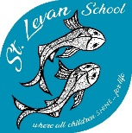
English Policy

St Levan Primary School
where all children SHINE-for life

Monitoring and review
The Headteacher is responsible for monitoring the implementation of this policy and for seeking the views of staff, children and parents. The Headteacher will report to the governing body on the effectiveness of this policy.

This policy was approved by the full governing body in May 2017. It is due for review by September 2019.

Contents
Introduction 2
Aims 2
Objectives 2
Strands 2
Speaking and Listening 3
Aims: 3
Teaching and Learning: 3
Reading 3
Aims: 4
Teaching and Learning: 5
Writing 5
Aims: 6
Teaching and Learning: 6
Grammar, Punctuation and Spelling: 6
Aims: 7
Teaching and Learning: 7
Planning 7
How we cater for pupils who are more able 8
Pupils with special educational needs and individual education plans 8
Role of Governors 8
English Resources: 8
Book corner which includes: 8
Writing area which includes: 9
Teaching resources: 9

Introduction
This policy aims to set out a consistent and explicit approach to teaching and learning in English across the school. It is based on the shared philosophy that, at St Levan Primary School, we believe one of the most important skills any child can leave primary school with is the ability to read independently and effectively for meaning. Through our enriched, topic-based curriculum, reading encompasses all areas of learning. We promote a culture of reading, not simply as a life skill, but to also develop in pupils a love of books and literature that will not only support their learning across the curriculum and allow them to succeed, but also enrich their future lives.

Aims
At St Levan we aim:
- To instil a passion for reading and writing and a love of literature
- To equip our pupils with the communication skills they will need in order to contribute to society and achieve economic wellbeing

Objectives
Our objectives in teaching English are that all children will:
- be able to communicate effectively and confidently in standard English;
- be able to listen to the spoken word attentively with understanding, pleasure and empathy;
- be able to read a range of materials fluently, critically and with understanding for enjoyment and for information;
- be able to write effectively for a range of audiences and purposes using spelling, punctuation and grammar accurately and confidently.

Strands
English teaching and learning at St Levan Primary School can be broken down into the following interlinked strands:
- speaking and listening
- reading (including phonics)
- writing (including handwriting)
- grammar, punctuation and spelling
Each of these strands will be outlined in more detail below.

Speaking and Listening
Effective communication is a key skill for life. The ability to speak and listen is fundamental to pupils’ language and social development. It is an essential tool for all areas of the curriculum, as talk underpins learning and thinking. It is vital that its significance is recognised by pupils, parents and teachers. Pupils need to be provided with many and varied contexts for talk, but they also need direct teaching in the skills of speaking and listening, including the ability to solve problems, share ideas and reflect on experiences.

Aims:
- To listen, evaluate and respect the opinion of others
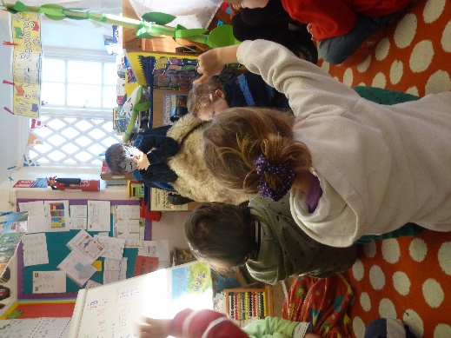
- To speak expressively and confidently about a range of topics through class discussions and debates
- To provide a range of opportunities for children to talk and listen in formal and informal settings
- To use drama and role play to develop confidence when addressing an audience
- To use discussion during shared and guided reading and writing sessions
- To create an environment in which children feel safe when speaking about their thoughts and feelings

Teaching and Learning:
- Use of talk partners
- Class discussions and debates
- Philosophy for Children
- Retelling stories and poetry
- Talk for Writing
- Role play and drama (including the Christmas Play, Summer performance, Central School of Drama week, John Brolly)
- Circle times
- Listening to and discussing a range of text types
- Story time/Reading lessons
- News sharing
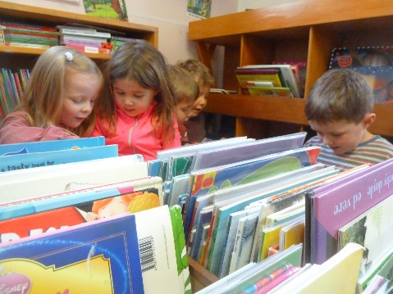
- Listening, responding to and evaluating their own and others’ contributions

Reading
Teachers promote and value reading as an enjoyable activity and a life skill. Teachers plan for a range of comprehension strategies that allow pupils to engage with text in a variety of ways to suit different learning styles (e.g. DERIC).
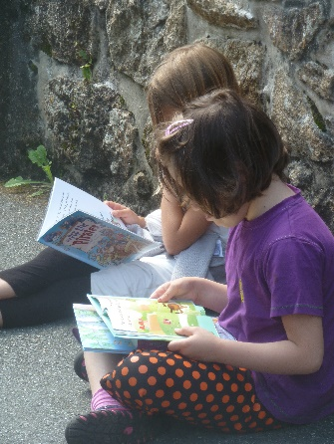
In shared reading the teacher models the reading process to the whole class as an expert reader providing a high level of support. Teaching objectives are pre-planned and sessions are characterised by explicit teaching of specific reading strategies, oral response and collaboration. Texts are rich and challenging, beyond the current reading ability of the majority of the class.
Teachers plan for independent reading activities during sessions of English teaching. Texts are selected so that pupils can access them without support. The focus for the reading is to provide practice and develop personal response to text.
Many other opportunities are provided for pupils to practise and extend reading in other subjects. Pupils select texts under the guidance of the teacher for independent and home/school reading. Teachers monitor independent reading and discuss progress with individual pupils on a regular basis.
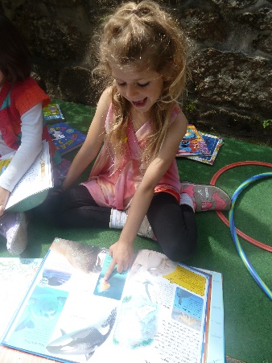
All teachers are responsible for providing a stimulating reading environment, promoting book ownership and recommending books to pupils. Classroom and central displays are language rich and special displays should promote authors and books.
Reading at home is regarded as an important part of reading development. Parents are encouraged to hear their children read regularly and respond to their child’s reading through Home-School Link Books.
All teachers are responsible for ensuring children have a broad reading curriculum which can include contextualised reading within a lesson, reading to the teacher, a TA or additional helper or taking part in shared reading with older/younger pupils.
The teaching of systematic synthetic phonics is outlined in more detail in the Phonics Policy.

Aims:
- To create a reading culture that celebrates a love and enjoyment of books
- To help children become critical readers to give them greater understanding of the wider world
- To provide a wide range of reading materials, e.g. big books, comics, newspapers, encyclopaedias, posters
- To develop children’s reading skills through using books graded according to challenge and difficulty
- To develop retrieval skills through a range of information texts, including those related to the class topic

Teaching and Learning:
- Experiences of hearing high quality texts (inc. Education Library Service topic boxes)
- Use of big books, audio and digital books for class reading and the teaching of reading strategies
- Modelled and shared reading
- Read and see plays performed
- Daily reading sessions using texts appropriate to level
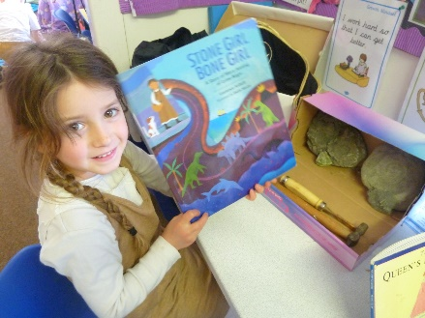
- Weekly reading lesson
- Regular opportunities to share books with the class teacher (KS2 class text)
- Interventions when appropriate, including reading volunteers and one-to-one activities linked to targets
- Opportunities for independent reading, both at school and at home
- Studying books by significant authors, including visits and projects
- Termly targets set with parents at parents’ meetings
- Termly topic books (sourced through Education Library Service) displayed in a reading-rich environment
- Reading areas to be welcoming and cosy
- Use of ‘book chums’ and reading dogs (Pippin)
- (D)ERIC (Decode, Explain, Retrieve, Interpret, Choice)

Writing
Teachers promote writing and look for ways to inspire and motivate pupils so that they see themselves as ‘writers’. Teachers establish the purpose and audience for writing and make teaching objectives explicit to pupils so they know why they are studying a particular text type, the kind of writing activities they need to undertake and what the expected outcome will be. The following teaching sequence for reading and writing will be used as a framework:
The writing process breaks down into a number of steps that will need to be taught and practised regularly:
- Planning
- Drafting and Writing
- Evaluating and Editing
- Proof-Reading
- Reading Aloud and Sharing
Subject-specific texts that link to work being undertaken in other areas should also be used in English lessons to support the wider curriculum. Teachers use shared writing to model the writing process and share good examples (WAGOLL: What A Good One Looks Like). Shared reading and writing provide a context for discussion and demonstration of grammatical features at word level, sentence level and text level. Activities are differentiated through the use of writing frames, spelling banks, collaborative work and peer or adult support. Teachers encourage ‘talk for writing’ as an integral part of the process.

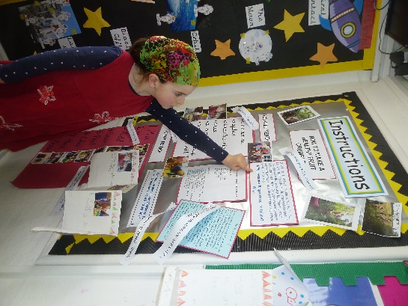
Aims:
- To understand the importance of audience and purpose
- To develop strategies to communicate effectively through the written word
- To write in a variety of forms
- To recognise that writing can be a collaborative effort
- To recognise that drafting and redrafting is an essential part of the writing process
- To join handwriting using a consistent cursive script

Teaching and Learning:
- Modelled, shared and guided writing
- Using dictionaries, class displays and a thesaurus to support the use of interesting vocabulary (wow words)
- Explicit teaching of new vocabulary through games and word mapping
- Children need to know and apply the steps taken in the drafting and editing process
- Opportunities to write from real life experiences
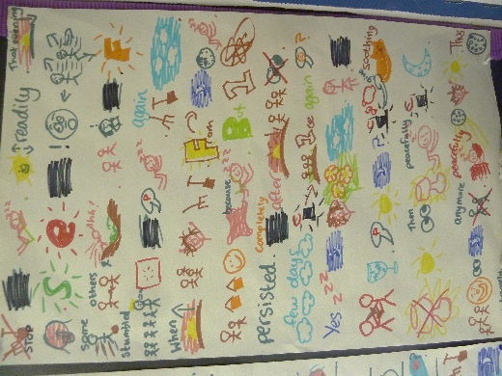
- Opportunities to write in a variety of forms and for different audiences, using high quality children’s books as a stimulus
- Grammar skills are taught in the context of writing for real purposes
- Opportunities to publish work through a variety of media
- Through marking, children are required to make improvements from teachers’ comments
- Peer and self-assessment against WALT and WILF
- Opportunities for writing across the curriculum
- Termly targets set with parents at parents’ meetings

Grammar, Punctuation and Spelling:
The grammar of our first language is learnt naturally and implicitly through interactions with other speakers and from reading. Explicit knowledge of grammar is, however, very important, as it gives us more conscious control and choice in our language. Building this knowledge is best achieved through a focus on grammar within the teaching of reading, writing and speaking.
The National Curriculum 2014
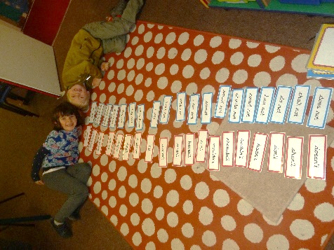
The teaching of Grammar, Punctuation and Spelling will be embedded within most English lessons and sometimes taught discretely. Links will also be made with other areas of the curriculum, as the understanding of Grammar, Punctuation and Spelling is intrinsic to our understanding of language whenever we are reading or writing.
At St Levan, the teaching of Grammar, Punctuation and Spelling will follow the 2014 National Curriculum, and the guidelines set out in its appendices. The teaching of spelling also follows on from the Read Write Inc scheme of teaching systematic synthetic phonics which children learn during the Early Years and KS1 (see phonics policy).

Aims:
- To recognise that spelling is an important skill and ensure that children have a range of strategies to move towards the conventions of the written word
- To allow children to become technicians of language, using appropriate terminology when discussing their writing
- To write in standard English for a range of purposes
- To ensure children meet the expected standard (inc. end of key stage assessments)

Teaching and Learning:
- Regular teaching of spelling linked to individual children’s needs and according to the requirements of the 2014 National Curriculum
- To make GPS relevant
- Weekly spellings practised and assessed in school time
- A range of strategies including ‘look, say, cover, write, check’, pneumonics, say it silly, spelling zappers etc.
- The marking of work (for specific spelling objectives and for practising high frequency words during take-up/purple pen time)
- Use of spelling journals to embed new/difficult vocabulary and words that do not conform to general conventions (Yr5/6)
- Encouragement of dictionary/thesaurus use.

Planning
- High quality children’s books are carefully chosen as a basis for rich learning experiences and to provide opportunities for writing with a purpose
- Teachers use their own individual plans but ensure they follow the SHINE model, clearly showing a reflection on previous learning, starter, differentiated main activity, plenary, assessment, resources and adult support.
- Plans are annotated during the week to record information for future planning
- Opportunities to share and discuss planning as a school team during staff meetings

How we cater for pupils who are more able
Where possible, more able pupils will be taught with their own class and stretched through differentiated group work and extra challenges. When working with the whole class, teachers will direct some questions towards the more able to maintain their involvement. Very occasionally, special arrangements will be made for an exceptionally gifted pupil e.g. they may be taught with children of a similar ability or may follow an individualised programme with more challenging tasks and activities, in order for them to broaden and deepen their understanding.

Pupils with special educational needs and individual education plans
Teachers aim to include all pupils fully in their daily English lessons. All children benefit from participating in modelled, shared and guided sessions. However a pupil whose difficulties are severe or complex may need to be supported with an individualised programme in the main part of the lesson.

Role of Governors
We have one named governor who assumes responsibility for the curriculum in the school by meeting regularly with the Headteacher and the Subject Leader. This governor has an overview of provision and standards in English teaching.

English Resources:
A comprehensive range of resources is available in school. Each class has a selection of reference books e.g. dictionaries, thesaurus etc. and a class library.
Teacher resources are located in classrooms. Guided reading books are kept in the school library alongside books which are banded according to colour. Some additional banded books are kept in the KS1 classroom. In addition, the school library contains a range of fiction and non-fiction books.

Book corner which includes:
- Picture books
- Range of fiction
- Big books
- Books made by children
- Religious books
- Books displayed front-on (rack)
- Book reviews
- Poems
- Comics
- Variety of non-fiction
- Cushions, rugs, dressing up boxes
- Toys
- Home/setting links
- Story visuals and posters (World Book Day)
- Topic books (Education Library Service)
- Book chums
- Audiobooks

Writing area which includes:
- Variety of writing tools, e.g. pencils, pens, chalks
- Visuals/word mats
- Paper
- Writing templates
- White boards and pens
- Tricky/common exception word display
- Alphabet
- Cursive writing poster
- Envelopes
- Writing checklists
- Read Write Inc. speed sounds (EY: simple, KS1/2: complex)

Teaching resources:
- Power of Reading resources from the CLPE website
- The Literacy Shed Plus
- Pi Corbett writing genre templates
- Twinkl
- Miss Wilson Says (DERIC)
- TES
- Twitter (people followed)
- CGP revision books (Yr6)
- Testbase
- Mappix (KS2 spellings)
- Elklan word mapping templates

